**University of Macau**

**Faculty of Science and Technology**

**Department of Computer and Information Science**



**CISC3003:** **Web Programming**

***The Pet Home Website***

**Submitted by Team 01:**

**DC026157 WONG KAI YUAN**

**DC328783 JOÃO PAULO MONTEIRO BARROS CEVA RODRIGUES**

**DC025027 AO CHI LAM**

**DC027353 CAO YUTING**

**DC027857 WANG XINYU**

**DC125943 WONG CHI CHON**

**DC126114 LEI CHAK FONG**

**Date of Submission: 2024/04/22**

**Introduction**

Welcome to PetHome, a cozy location created for the devoted pet community. Our virtual website welcomes a wide range of animal enthusiasts, from long-time pet owners to those just starting out in the world of pet ownership. PetHome goes beyond the typical confines of an internet platform to become a lively, engaged community where everyone speaks the same language—love for pets. PetHome provides a wide range of experiences, materials, and services that address every facet of pet care and companionship because of their profound awareness of the special link that exists between pets and their owners.

**Our Goal**

At the heart of PetHome is the aspiration to weave a tapestry of connections among pets and their owners that is as enduring as it is enriching. We aim to be the leading online platform that not only streamlines the practical aspects of pet ownership but also cultivates a warm, informed, and vibrant community. PetHome envisions becoming an integral part of the daily lives of pet lovers, where support, advice, and quality care products are readily accessible. By fostering a nurturing space for education, community interaction, and easy access to essential pet products, we are dedicated to enhancing and celebrating the human-pet relationship at every level.

**The main services provided by the system**

PetHome distinguishes itself by offering a user-centric interface that prioritizes easy connectivity, the exchange of knowledge, and a specialized online storefront for pet care essentials.



1. Login/Register:   
   PetHome simplifies the process of creating a secure account, empowering users to contribute to forums, pen insightful blog entries, and indulge in a seamless shopping experience.
2. Community Forums:   
   This space is the heartbeat of PetHome, where members engage in lively discussions, dispense and receive advice, and strengthen their bonds over shared pet-rearing experiences.
3. Blog:   
   An educational treasury populated with articles from pet care experts, the blog serves as a trove of knowledge for pet wellness and upkeep.
4. Store Page:   
   Featuring a handpicked assortment of pet supplies, our store meets every possible need, ensuring pets are well-fed, entertained, and cared for with our diverse product range.

**Our target user**

1. Novice Pet Owners: For those just starting out, feeling both the excitement and the uncertainty of welcoming a new pet into their home. PetHome provides a nurturing environment full of guidance, support, and essential products to ensure a smooth beginning to their pet-care journey.
2. Experienced Pet Guardians: Veteran pet owners will find advanced resources, community forums for in-depth discussions, and a comprehensive range of products to support the continued well-being of their companions.
3. Urban Pet Lovers: Our platform is ideal for those residing in bustling cities, seeking advice on raising pets in smaller living spaces and connecting with other urban pet owners for shared experiences and tips.
4. Community Seekers: Individuals looking for a sense of belonging and interaction with like-minded pet lovers. PetHome's forums and blogs foster a sense of community and mutual support.
5. Conscientious Shoppers: Users who value convenience without compromising on the quality and variety of pet care supplies. PetHome’s online store offers a curated selection of products to fit their lifestyle and their pets' needs.

**User Workflow**

From the first click, visitors to PetHome are greeted by a well-organized homepage that intuitively guides them to the site's prominent features, ensuring a welcoming and navigable user journey.

Key User Interactions:

* Shopping: With a variety of pet products on offer, the store page is a one-stop-shop for all pet care necessities, providing an enriching shopping experience.
* Engagement: The forum invites users to dive into rich dialogues, share anecdotes, and seek counsel, all in the spirit of enhancing life with pets.
* Knowledge Expansion: The blog stands as a pillar of PetHome, offering comprehensive articles that delve into pet health, behavioral insights, and nutritional advice.

**Platform Structure**

* Home: Serving as the launchpad into PetHome, the home page provides an overview of all the key areas within the site.  
  A screenshot of a website

  Description automatically generated
* Forum: A dynamic platform for community support, advice, and shared stories, the forum nurtures the collective wisdom of pet lovers.  
  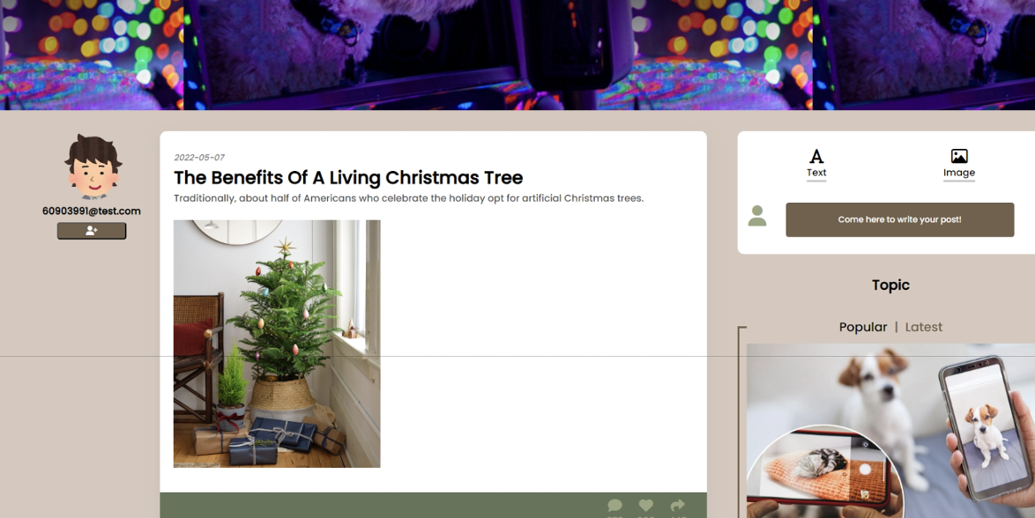
* Blog: A library of expertise, the blog is continuously updated with valuable guidance on all aspects of pet care.  
  A screenshot of a website

  Description automatically generated
* Store: A diverse marketplace, the store fronts an extensive selection of pet products, from daily necessities to luxury items.  
  A screenshot of a website

  Description automatically generated
* Login/SignUp: With a focus on security and customization, these pages offer streamlined account access for a more personal user experience.  
  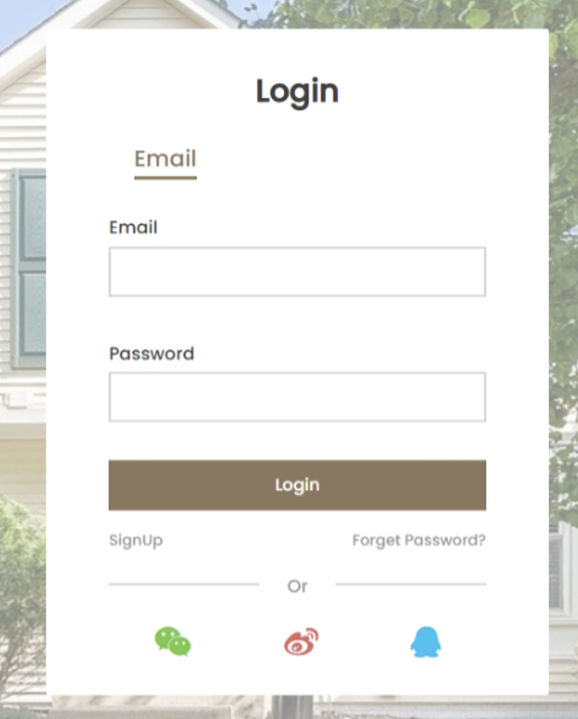
* Cart: The cart system is designed for ease, allowing users to manage their selections and proceed to checkout with confidence.

**Technical Vision**

Crafted with the latest web technologies, PetHome presents an intuitive, responsive H5 website, employing HTML and CSS for an aesthetically pleasing and user-friendly interface. We integrate PHP to handle dynamic content and MySQL for secure, efficient data management. Tools such as PHPMailer will be deployed to streamline user communication, including the dispatch of account activation links and other notifications, ensuring a robust and engaging platform that prioritizes user satisfaction and security.